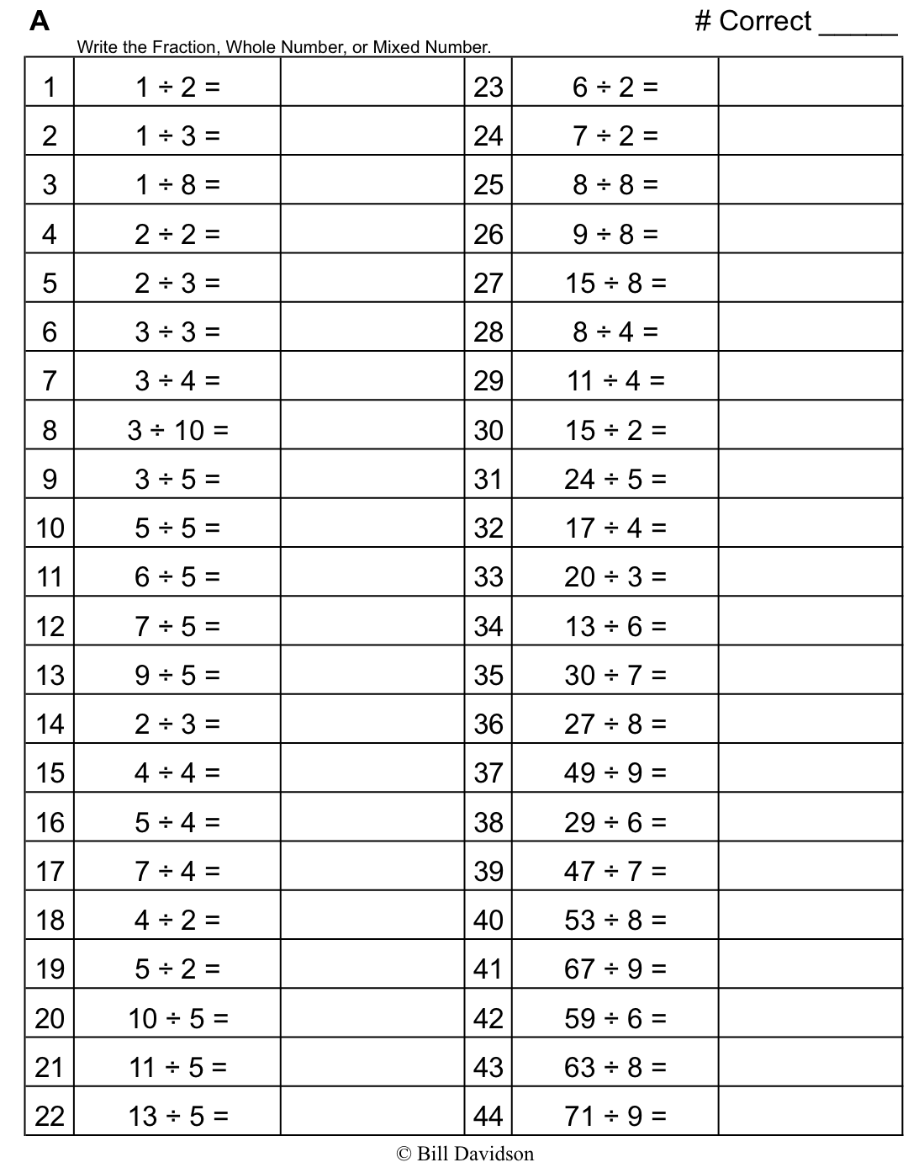
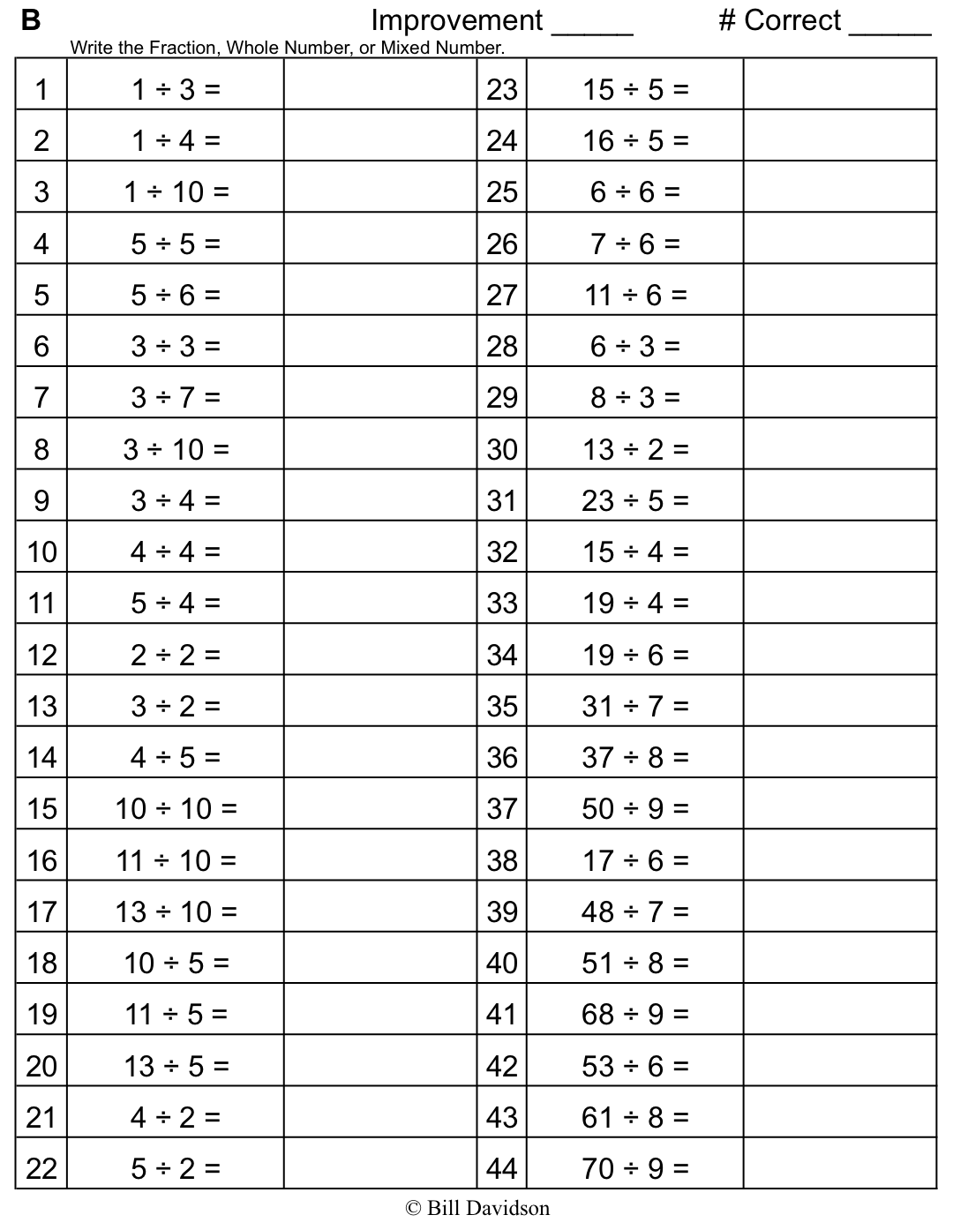

Name Date
- Find the value of each of the following.

a. b.
$\frac{1}{3}$ of 15 =
$\frac{2}{3}$ of 15 =
$\frac{3}{3}$ of 15 =

$\frac{1}{3}$ of 9 =
$\frac{2}{3}$ of 9 =
$\frac{3}{3}$ of 9 =

c.

$\frac{1}{5}$ of 20=
$\frac{4}{5}$ of 20 =
$\frac{}{5}$ of 20 = 20

$\frac{1}{8}$ of 24 = $\frac{6}{8}$ of 24 =

$\frac{3}{8}$ of 24 = $\frac{7}{8}$ of 24 =

$\frac{4}{8}$ of 24 =

- Find $\frac{4}{7}$ of 14. Draw a set and shade to show your thinking.

- How does knowing $\frac{1}{8}$ of 24 help you find three-eighths of 24? Draw a picture to explain your thinking.

- There are 32 students in a class. Of the class, $\frac{3}{8}$ bring their own lunch. How many students bring their lunch?

- Jack collected 18 ten dollar bills while selling tickets for a show. He gave $\frac{1}{6}$ of the bills to the theater and kept the rest. How much money did he keep?

Name Date
- Find the value of each of the following.

♥ ♥  ♥ ♥ | ♥ ♥  ♥ ♥ | ♥ ♥  ♥ ♥ | ♥ ♥  ♥ ♥

- $\frac{1}{4}$ of 16 =

- $\frac{3}{4}$ of 16 =

- Out of 18 cookies, $\frac{2}{3}$ are chocolate chip. How many of the cookies are chocolate chip?

Name Date
- Find the value of each of the following.

♦ ♦  ♦ ♦ | ♦ ♦  ♦ ♦ | ♦ ♦  ♦ ♦

$\frac{1}{3}$ of 12 =

$\frac{2}{3}$ of 12 =

$\frac{3}{3}$ of 12 =

♦ ♦  ♦  ♦ ♦ | ♦ ♦  ♦  ♦ ♦ | ♦ ♦  ♦  ♦ ♦ | ♦ ♦  ♦  ♦ ♦

$\frac{1}{4}$ of 20 = $\frac{3}{4}$ of 20 =

$\frac{2}{4}$ of 20 = $\frac{4}{4}$ of 20 =

♦ ♦ ♦ ♦ ♦ ♦ ♦
♦ ♦ ♦ ♦ ♦ ♦ ♦
♦ ♦ ♦ ♦ ♦ ♦ ♦
♦ ♦ ♦ ♦ ♦ ♦ ♦
♦ ♦ ♦ ♦ ♦ ♦ ♦

$\frac{1}{5}$ of 35 = $\frac{3}{5}$ of 35 = $\frac{5}{5}$ of 35 =

$\frac{2}{5}$ of 35 = $\frac{4}{5}$ of 35 = $\frac{6}{5}$ of 35 =
- Find $\frac{2}{3}$ of 18. Draw a set and shade to show your thinking.

- How does knowing $\frac{1}{5}$of 10 help you find $\frac{3}{5}$ of 10? Draw a picture to explain your thinking.

- Sara just turned 18 years old. She spent $\frac{4}{9}$ of her life living in Rochester, NY. For how many years did Sara live in Rochester?

- A farmer collects 12 dozen eggs from her chickens. She sells $\frac{5}{6}$ of the eggs at the farmers’ market and gives the rest to friends and neighbors.

a. How many eggs does she give away?

b. If she sells each dozen for $4.50, how much will she earn from the eggs she sells?

