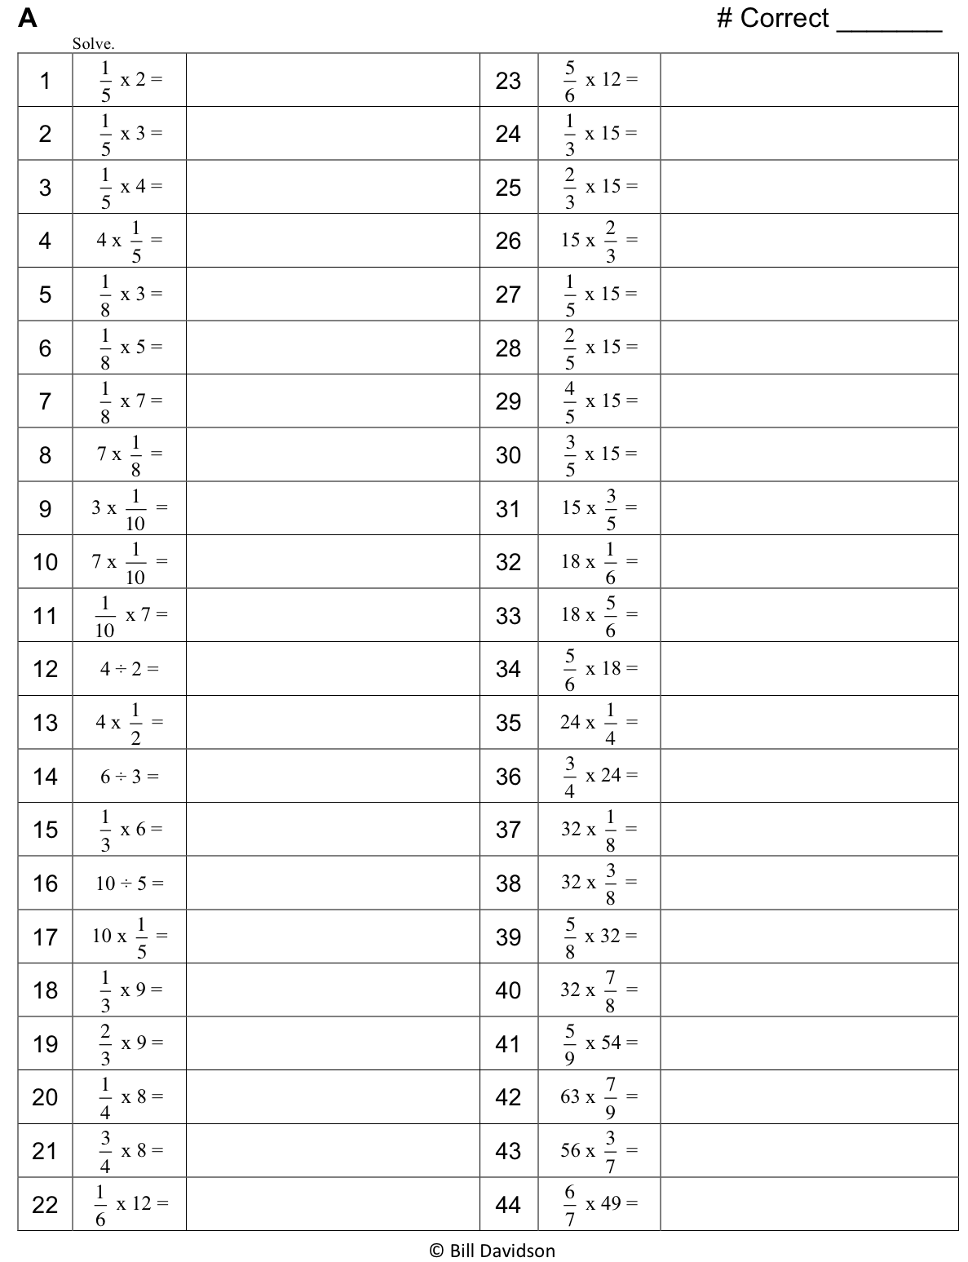

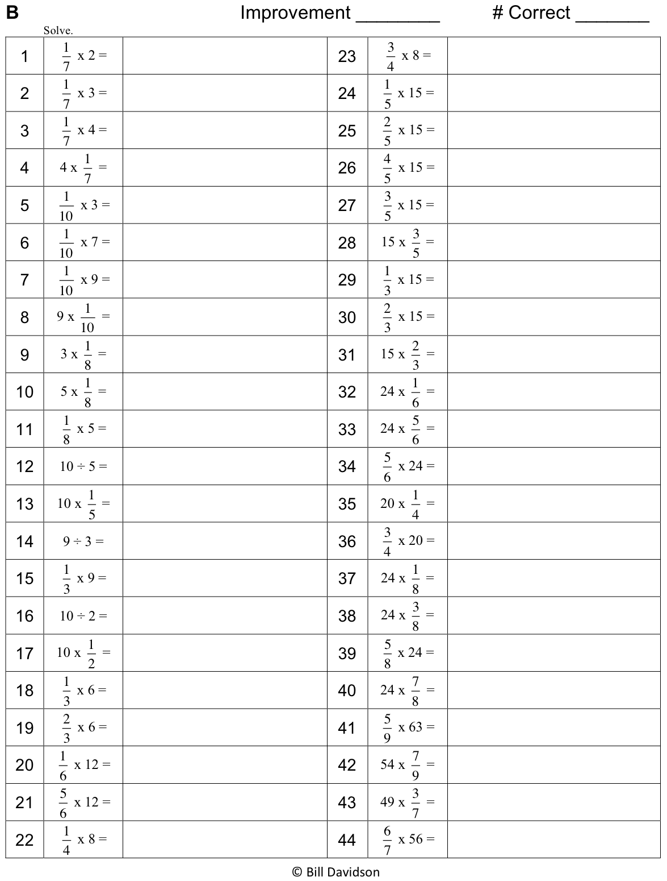
Name Date
- Use the prisms to find the volume.
- Build the rectangular prism pictured below to the left with your cubes, if necessary.
- Decompose it into layers in three different ways, and show your thinking on the blank prisms.
- Complete the missing information in the table.
Number of Layers | Number of Cubes in Each Layer | Volume of the Prism
 |  | cubic cm
 |  | cubic cm
 |  | cubic cm

a.

b.
Number of Layers | Number of Cubes in Each Layer | Volume of the Prism
 |  | cubic cm
 |  | cubic cm
 |  | cubic cm

2. Josh and Jonah were finding the volume of the prism to the right. The boys agree that 4 layers can be added together to find the volume. Josh says that he can see on the end of the prism that each layer will have 16 cubes in it. Jonah says that each layer has 24 cubes in it. Who is right? Explain how you know using words, numbers, and/or pictures.

- Marcos makes a prism 1 inch by 5 inches by 5 inches. He then decides to create layers equal to his first one. Fill in the chart below, and explain how you know the volume of each new prism.
Number of Layers | Volume | Explanation
2
4
7

- Imagine the rectangular prism below is 6 meters long, 4 meters tall, and 2 meters wide. Draw horizontal lines to show how the prism could be decomposed into layers that are 1 meter in height.

It has _____ layers from bottom to top.
Each layer contains ______ cubic units.
The volume of this prism is __________.

Name Date
- Use unit cubes to build the figure to the right and fill in the missing information.
Number of layers: _______
Number of cubes in each layer: ______
Volume: ______ cubic centimeters

- This prism measures 3 units by 4 units by 2 units. Draw the layers as indicated.
Number of layers: 4
Number of cubic units in each layer: 6
Volume: ______ cubic centimeters

Name Date
- Use the prisms to find the volume.
- The rectangular prisms pictured below were constructed with 1 cm cubes.
- Decompose each prism into layers in three different ways, and show your thinking on the blank prisms.
- Complete each table.
Number of Layers | Number of Cubes in Each Layer | Volume of the Prism
 |  | cubic cm
 |  | cubic cm
 |  | cubic cm

a.

Number of Layers | Number of Cubes in Each Layer | Volume of the Prism
 |  | cubic cm
 |  | cubic cm
 |  | cubic cm
b.

- Stephen and Chelsea want to increase the volume of this prism by 72 cubic centimeters. Chelsea wants to add eight layers, and Stephen says they only need to add four layers. Their teacher tells them they are both correct. Explain how this is possible.

- Juliana makes a prism 4 inches across and 4 inches wide but only 1 inch tall. She then decides to create layers equal to her first one. Fill in the chart below, and explain how you know the volume of each new prism.
Number of Layers | Volume | Explanation
3
5
7

- Imagine the rectangular prism below is 4 meters long, 3 meters tall, and 2 meters wide. Draw horizontal lines to show how the prism could be decomposed into layers that are 1 meter in height.

It has _____ layers from left to right.
Each layer contains ______ cubic units.
The volume of this prism is __________.
Name Date
Use these rectangular prisms to record the layers that you count.

rectangular prism recording sheet

